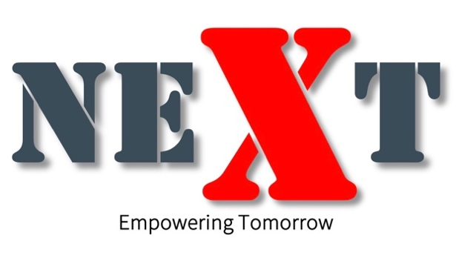

the NEXT Token White Paper

Chairman’s Note
The NEXT Token is a ground breaking digital asset designed to deliver stability, consistent value appreciation, and long-term scalability. By seamlessly integrating sustainable energy finance (e-Fi), a concept pioneered by NEXT Token with blockchain technology, it offers a transformative approach to combining real-world utility with cutting-edge digital solutions.
Gone are the days of speculative promises—NEXT Token focuses on developing real-world utilities (RWU) that generate tangible demand for today and the future. With a high entry barrier, electricity generation is a specialized industry requiring expertise and infrastructure, not accessible to just anyone. Leveraging over two decades of energy generation experience, NEXT is uniquely positioned to bridge the gap between energy producers and users.
As the first Real World Utility token, NEXT Token creates a seamless connection between energy producers and users, integrating energy supply directly into its token ecosystem. This enhances efficiency, accessibility, and consistent value growth.

Part 1: Core Value Proposition
Dual-Benefit Model
NEXT Token offers participants two distinct products tailored to meet diverse needs within the energy and finance ecosystem:
- NEXT Proof of Energy (NPoE) – A long-term participation model designed to provide stability and predictable outcomes.
- NEXT Power Blocks – A structured product offering steady, periodic engagement with tangible links to real-world energy infrastructure.
These products form the foundation of NEXT Token’s innovative approach, combining energy production with financial tools to deliver both scalability and real-world utility.

Stable and Appreciating Value
NEXT Token’s value is firmly linked to electricity generation and infrastructure development. This ensures stability while enabling consistent appreciation as the ecosystem grows.

NEXT Token: Transforming Energy and Finance (e-Fi)
NEXT Token is more than just a digital asset—it is a revolutionary ENERGY Digital Asset that bridges the gap between energy production and financial innovation. By combining stability, utility, and scalability, NEXT Token is positioned to lead the digital economy with sustainable energy solutions.

Stability and Scalability
The NEXT Token ecosystem is designed to meet the rising demands of energy-intensive industries such as data centers and industrial parks while maintaining scalability and adaptability:
- Consistent Growth: NEXT Token’s value scales with its expanding energy production capacity and operational footprint.
- Adaptability: The ecosystem evolves to address global energy challenges with modular infrastructure and innovative tools.

Why Choose NEXT Token?
1. Expertise in Energy Generation
With over two decades of experience in energy generation, NEXT possesses the infrastructure and credibility to pioneer the world’s first Real-World Utility (RWU) energy token.
2. Innovative Financial Products
NEXT Token introduces dual financial tools that integrate real-world utility with financial innovation:
- NPoE: For participants focused on long-term outcomes.
- Power Blocks: For those seeking structured, periodic engagement.
3. Real-World Utility (RWU)
NEXT Token powers industrial parks and data centers as the primary currency for:
- Utility payments,
- Rentals, and
- Energy services.
This integration ensures continuous demand for the token while creating value across high-demand sectors.
4. Sustainability and ESG Alignment
NEXT Token aligns with global environmental goals by:
- Focusing on renewable energy integration to minimize carbon footprints.
- Attracting ESG-conscious participants who prioritize sustainability.

NEXT Energy Digital Index (NEDI)
NEDI is a decentralized energy index that supports transparency and efficiency within the NEXT ecosystem. It serves as the backbone for energy trading, pricing, and market insights, providing participants with actionable data while reinforcing the token’s value and utility.

Stable and Appreciating Value
NEXT Token is designed to ensure long-term stability and appreciation through:
- Controlled Supply: Limited availability ensures scarcity and sustained demand.
- Scalable Integration: Expanding use cases drive adoption and consistent growth.

NEXT Token: Transforming Energy and Finance (e-Fi)
NEXT Token is a pioneering ENERGY Digital Asset combining stability, scalability, and real-world utility. With its dual-product model and robust ecosystem infrastructure supported by NEDI, NEXT Token delivers unmatched opportunities for participants seeking sustainable growth and long-term value.

Part 2: The Importance of Electricity and Energy Finance (e-Fi)
Electricity: A Growing Global Need
Electricity demand is rising rapidly across the globe, driven by industrialization, urbanization, and advancements in technology such as AI, IoT, and cloud computing. As more industries and households rely on electricity, its cost and accessibility have become critical concerns.
Challenges in the Energy Sector:
- Rising Costs: Energy prices are increasing steadily, placing financial pressure on businesses and consumers.
- Supply-Demand Imbalance: The gap between energy production and consumption highlights inefficiencies in the existing energy system.
- Lack of Innovation: Traditional energy systems struggle to adapt to modern financial and operational demands.

Energy Finance (e-Fi) by NEXT
NEXT Token introduces Energy Finance (e-Fi), an innovative approach that bridges the gap between energy production and finance. Through blockchain technology and real-world utility, NEXT Token redefines how energy assets are monetized and utilized.
Key Features of e-Fi:
- Transparency: A decentralized platform ensures all transactions are clear and traceable.
- Efficiency: By integrating energy production with financial tools, e-Fi eliminates inefficiencies in traditional systems.
- Scalability: The e-Fi model evolves alongside growing energy demands, ensuring long-term relevance.

Dual Products: NPoE and Power Blocks
To address these challenges, NEXT Token offers two distinct products:
- NEXT Proof of Energy (NPoE):
  - Designed for participants seeking long-term engagement.
  - Provides a stable and predictable model for sustained outcomes.
- NEXT Power Blocks:
  - Tailored for structured, periodic engagement.
  - Offers steady opportunities linked to real-world energy infrastructure.
These products empower participants to directly engage with energy finance, making it accessible, transparent, and scalable.

Why e-Fi is Transformative
The e-Fi approach by NEXT is a game-changer for the energy and financial sectors:
- It connects producers, consumers, and participants in a seamless ecosystem.
- It ensures fair pricing, operational efficiency, and financial inclusivity.
- It provides a sustainable model for addressing rising global energy demands.

Conclusion
Electricity is the foundation of modern life, and its growing demand requires innovative solutions. NEXT Token’s e-Fi model addresses these needs by combining blockchain technology with energy production, offering participants a transparent and scalable way to engage with energy-driven opportunities.
With its dual products, NPoE and Power Blocks, NEXT Token is set to transform the energy sector, ensuring accessibility, sustainability, and profitability for all stakeholders.

Part 3: NEXT Energy Block Trading and Proof of Energy (NPoE)
NEXT Token: A Dual-Product Ecosystem
NEXT Token empowers participants through two distinct products tailored to meet diverse needs:
- NEXT Proof of Energy (NPoE) – A long-term participation model for predictable, sustained outcomes.
- NEXT Power Blocks – A structured product offering steady, periodic engagement tied to real-world energy infrastructure.
These products are seamlessly integrated with NEXT’s energy production and financial systems, creating a transformative ecosystem for participants.

NEXT Energy Block Trading
Energy Blocks represent tokenized energy assets that allow participants to engage directly with energy-driven opportunities.
Key Features of Energy Blocks:
- Scalability: Modular and flexible, Energy Blocks adapt to global energy demands.
- Transparency: Backed by decentralized systems, ensuring clear and traceable engagement.
- Real-World Connection: Linked to tangible energy infrastructure, providing stability and reliability.

NEXT Proof of Energy (NPoE)
NPoE is a blockchain-driven financial model that enables long-term engagement with predictable outcomes.
Key Features:
- Sustainability: NPoE is designed to provide consistent outcomes aligned with energy production.
- Transparency: Blockchain-based systems ensure trust and clarity for participants.
- Long-Term Engagement: Encourages stability through sustained participation.

Why Choose These Products?
- Dual Opportunities: Participants can choose between long-term stability (NPoE) or structured periodic engagement (Power Blocks).
- Real-World Utility (RWU): Both products are directly linked to NEXT’s energy infrastructure and token utility.
- Scalability: Products are designed to adapt to global energy demands and market conditions.

Conclusion
NEXT Energy Block Trading and NPoE redefine how participants engage with energy and finance. By offering scalable, transparent, and utility-driven products, NEXT Token establishes itself as a cornerstone of the global energy economy, delivering value for participants and industries alike.

Part 4: Scalability of the NEXT Ecosystem
Inherently Scalable and Adaptable
The NEXT Token ecosystem is engineered for scalability, ensuring it can meet rising global energy demands while consistently delivering value to participants. By integrating robust energy infrastructure with innovative financial models, NEXT creates a sustainable growth trajectory that aligns with global market needs.

Electricity Generation Capabilities
The ecosystem is built to support energy-intensive industries, such as data centers and industrial parks, through scalable energy production:
- Capacity Range: From 1,000 MW to 5,000 MW, catering to diverse market demands.
- Revenue Potential: Each additional MW directly contributes to increased revenue, establishing a sustainable and predictable growth model.

Key Drivers of Scalability
1. Electricity Generation and Revenue Potential
- Stable and Scalable Revenue: NEXT operations provide reliable income streams backed by scalable energy production.
- Revenue Metrics: Energy generation offers annual revenue potential ranging from USD 262 million to USD 1.3 billion, with a 3-cent profit per kWh.
- Modular Power Blocks: These scalable units allow cost-efficient and incremental deployment, ensuring flexibility and rapid growth across diverse regions.

2. Global Expansion Opportunities
NEXT is strategically positioned to replicate its model in high-demand markets, including:
- Industrial Parks: Focus on scalable hubs for manufacturing and logistics.
- Data Centers: High energy consumers driven by digital transformation.
- Emerging Markets: Addressing energy shortages in rapidly growing economies.
Key Strategies:
- Five Additional Industrial Parks: Scalable modules are ready for deployment in the same region and globally.
- Strategic Partnerships: Collaborations maximize market alignment and profitability.
- Precise Site Selection: Ensures efficient operations and high return on investment.

3. Energy Finance (e-Fi) as a Global Standard
NEXT introduces Energy Finance (e-Fi) as a transformative financial model, designed to:
- Tokenize Energy Assets: Create a transparent and accessible marketplace for energy trading and investments.
- Global Standardization: Bridge the gap between energy producers and users, making energy engagement scalable and efficient.

How Scalability Creates Value
1. Sustained Energy Production Growth
- Modular Power Blocks enable incremental energy generation tailored to market needs.
- Each 1,000 MW contributes USD 262.8 million in annual revenue, ensuring predictable growth.
2. Geographic Expansion
- Scalable infrastructure allows NEXT to replicate its success across new regions.
- Strategic market analysis ensures entry into high-demand and profitable markets.
3. Diverse Industrial Park Revenue Streams
NEXT industrial parks generate multiple revenue streams, including:
- Utilities: Energy and water services.
- Rentals: Land and facility leases.
- Land Sales: Strategic real estate opportunities.
4. Enhanced Token Utility
NEXT Token is the primary currency within the ecosystem, used for:
- Utility payments.
- Rentals.
- Land transactions.
This integration creates a synergistic relationship between electricity demand and token utility, enhancing ecosystem sustainability.
5. Token Appreciation and Participant Benefits
- Limited Supply: Drives scarcity and value appreciation.
- Long-Term Value: Increased token utility ensures consistent growth.
- Participant Rewards:
  - Yeilds for long-term holders.
  - Steady returns from energy block engagement.
  - Capital appreciation through ecosystem growth.

Conclusion
The NEXT Token ecosystem’s scalability ensures it can address the rising global energy demand while solidifying its position as a sustainable and profitable model. With modular Power Block technology, strategic global expansion, and a robust e-Fi framework, NEXT establishes itself as a leader in energy-driven digital finance, empowering participants and industries worldwide.

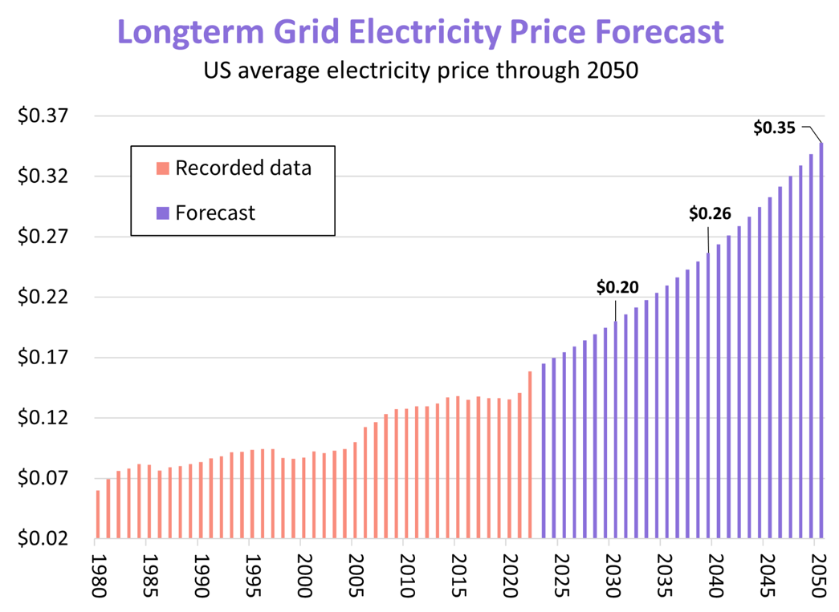

Part 5: NEXT Token Mechanics
Introduction to NEXT Token Products
NEXT Token offers two distinct products designed to meet diverse participant needs within its ecosystem:
- NEXT Proof of Energy (NPoE):
A long-term engagement model aligned with the ecosystem’s energy production, providing stable and predictable participation opportunities.
- NEXT Power Blocks:
A structured, periodic model offering steady payouts while maintaining flexibility and accessibility for participants.
These products form the foundation of NEXT Token’s dual-product system, ensuring both scalability and participant engagement.

1. NEXT Proof of Energy (NPoE)
NPoE is a blockchain-driven model that enables participants to engage with energy assets through predictable, long-term opportunities.
Key Features:
- Predictable Long-Term Outcomes: Tailored for participants seeking consistent and stable returns over an extended period.
- Blockchain Security: Smart contracts ensure transparency, automation, and immutability.
- Alignment with Energy Production: NPoE reflects NEXT’s commitment to tangible, sustainable assets.

2. NEXT Power Blocks
NEXT Power Blocks provide a structured and periodic model for participants who prefer steady payouts with principal protection.
Key Features:
- Structured Participation: Offers periodic payouts throughout the engagement period, ideal for participants seeking regular income streams.
- Principal Security: Ensures the initial participation is preserved while providing consistent payouts.
- Scalability: Modular deployment enables flexibility, ensuring Power Blocks can adapt to varying participant needs and global energy demands.

Key Differences Between NPoE and Power Blocks

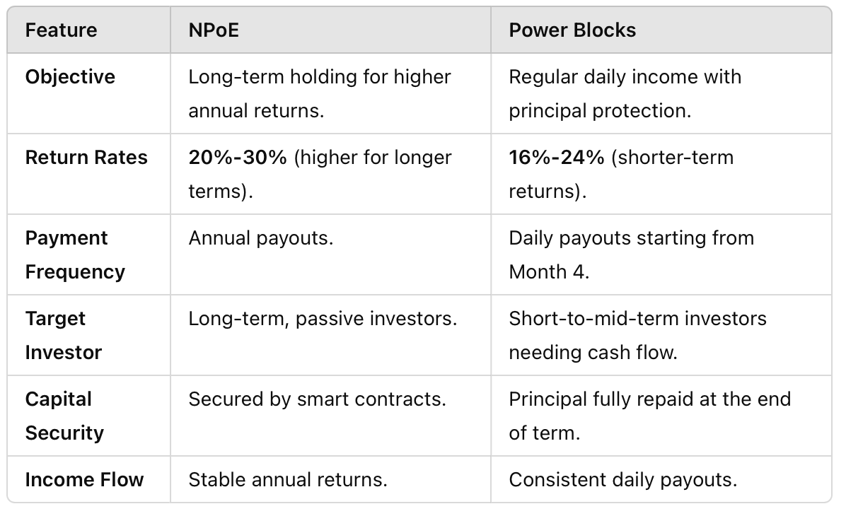

How These Products Work Together
- Dual Opportunity: Participants can choose NPoE for long-term outcomes or Power Blocks for shorter-term, structured engagement.
- Real-World Connection: Both products are directly tied to NEXT’s energy production and infrastructure, ensuring tangible value for participants.
- Enhanced Token Utility: Participants use NEXT Token as the primary currency for these products, driving adoption and token circulation within the ecosystem.

Participant Benefits
- Flexibility: Tailored options ensure participants can engage based on their individual goals and time horizons.
- Transparency: Blockchain technology guarantees a secure and reliable engagement process.
- Sustainability: Both products align with NEXT’s mission to create a scalable and environmentally conscious energy ecosystem.

Conclusion
NEXT Token’s dual-product system combines long-term stability with structured, periodic opportunities, catering to a wide range of participant preferences. By integrating these products with its real-world energy infrastructure, NEXT creates a scalable, transparent, and sustainable ecosystem that bridges the gap between energy and finance.

Part 6: Integration with Industrial Parks and Data Centers
Seamless Integration into Real-World Applications
NEXT Token is not just a financial instrument—it is seamlessly embedded into the operations of industrial parks and data centers, serving as the primary transactional asset within a growing ecosystem.

Key Use Cases
1. Utility Payments
- Tenants use NEXT Token to pay for essential utilities, including electricity, water, and gas, ensuring smooth transactions and driving continuous token demand.
2. Rentals
- Land and facility rentals within the industrial parks are conducted in NEXT Token, enhancing liquidity and circulation of the token.
3. Data Center Services
- NEXT Token powers energy-efficient data center operations, promoting adoption by businesses with significant energy needs.

Key Benefits for Participants
1. Steady Returns
- Participants benefit from consistent income streams through fixed daily payouts, ensuring financial stability while safeguarding principal investments.
2. Immediate Utility
- NEXT Token generates returns even when held, offering participants ongoing value and incentives for engagement.
3. Tangible Revenue Link
- Backed by electricity generation, the token’s value is directly tied to real-world infrastructure, ensuring both stability and growth.
4. Long-Term Value
- The increasing demand for NEXT Token, driven by its use in industrial parks and data centers, naturally contributes to value appreciation over time.

How Integration Drives Sustainability
NEXT Token’s integration within industrial parks and data centers creates a self-sustaining ecosystem:
- Continuous Token Demand: Essential operational activities—utility payments, rentals, and services—ensure ongoing token circulation.
- Scalability: As industrial parks and data centers expand globally, token adoption grows in tandem, reinforcing its value.
- Synergy with Energy Finance: The token integrates seamlessly with NPoE and Power Blocks, aligning energy production with financial engagement for a robust ecosystem.

Conclusion
NEXT Token bridges blockchain technology with real-world energy finance, creating a self-sustaining ecosystem that drives continuous token demand and long-term value appreciation. By powering industrial parks and data centers, the token ensures scalability, liquidity, and tangible utility for participants.
With its seamless integration into industrial operations, NEXT Token offers a compelling opportunity for participants seeking stability, predictable income, and a foothold in the future of energy-driven finance.

Part 7: Token Utility, Financial Incentives, and How Scalability Reduces Token Risk
Token Utility Across the Ecosystem
NEXT Token serves as the cornerstone of a dynamic ecosystem, driving continuous demand through its integration into industrial parks, data centers, and energy finance products.
Primary Utility Areas:
- Utility Payments: NEXT Token is the currency for electricity, water, and gas payments within industrial parks.
- Rental Transactions: Land and facility rentals are conducted exclusively in NEXT Token.
- Energy Finance Products: NPoE and Power Blocks rely on NEXT Token for participation, increasing circulation.
These applications ensure NEXT Token’s utility grows as the ecosystem scales, making it an indispensable asset within the NEXT ecosystem.

Financial Incentives for Participants
NEXT Token is designed to deliver consistent returns and long-term growth potential for participants:
- Engagement Opportunities
  - NPoE: Ideal for participants seeking long-term stability.
  - Power Blocks: Provides steady, periodic payouts for predictable income.
- Predictable Returns
  - Energy finance products are tied to real-world energy assets, providing participants with stability and reliability.
- Yield Potential
  - Long-term holders benefit from yeilds tied to the profitability of NEXT’s energy and industrial operations.

How Scalability Reduces Token Risk
1. Demand Anchored in Real-World Utility
- Utility payments, rentals, and services in industrial parks ensure consistent token demand.
- Integration with data centers and global energy finance products diversifies demand sources.
2. Multiple Revenue Streams
- Revenue generated from industrial park operations, including utilities, rentals, and land sales, creates a robust financial backbone.
- Energy finance products further diversify revenue sources, reducing dependence on any single stream.
3. Controlled Token Supply
- Modular scalability ensures that token issuance aligns with ecosystem expansion, avoiding oversupply.
- Incremental scaling of Power Blocks and
energy production allows the ecosystem to grow sustainably without overextending resources.

4. Long-Term Value Stability
- Tied directly to tangible energy assets and proven infrastructure, NEXT Token is less prone to speculative volatility.
- The alignment with real-world operations ensures that token value grows steadily alongside the ecosystem.
5. Risk Mitigation Through Decentralization
- Blockchain technology ensures transparency, security, and decentralized control, reducing systemic risks.
- Participants can trust that operations are backed by immutable smart contracts and efficient tokenomics.

Conclusion
NEXT Token’s utility, financial incentives, and scalability combine to create a robust and secure investment ecosystem. The token’s role as the backbone of industrial park operations and energy finance products ensures continuous demand and long-term value.
By leveraging real-world applications, multiple revenue streams, and controlled scalability, NEXT Token minimizes risk and maximizes growth potential. It is a sustainable and attractive option for participants seeking stability, predictable returns, and long-term value creation.

Part 8: Strategic Roadmap and Future Growth
NEXT: Building the Future of Energy and Finance
NEXT Token’s strategic roadmap outlines a clear and achievable vision for the future, focusing on scalability, innovation, and global expansion. By leveraging its dual-product system and real-world energy integration, NEXT aims to redefine the energy economy and digital finance landscape.

Key Phases of Growth
Phase 1: Foundation and Launch
- Establish the initial industrial park with integrated energy infrastructure.
- Launch NEXT Proof of Energy (NPoE) and Power Blocks products.
- Ensure the ecosystem’s stability through scalable energy production (1,000 MW).
Phase 2: Expansion and Utility Growth
- Deploy five additional industrial parks in key global regions.
- Scale energy production to 5,000 MW to meet increasing demands.
- Expand token utility within data centers, industrial parks, and energy finance markets.
- Strengthen strategic partnerships to drive adoption and ecosystem trust.
Phase 3: Global Standardization and Market Leadership
- Establish NEXT as the global leader in Energy Finance (e-Fi) by expanding NPoE and Power Blocks adoption.
- Position NEXT Token as the default transactional currency for energy payments and rentals in industrial parks.
- Scale the NEXT Energy Digital Index (NEDI) to support global energy trading and financial transparency.

Focus Areas for Sustainable Growth
1. Energy Production and Infrastructure
- Expand modular Power Block units to meet energy demands efficiently.
- Increase renewable energy integration to align with global ESG goals.
2. Technology and Innovation
- Advance blockchain integration to enhance security and transparency.
- Develop smart grid and IoT solutions for efficient energy management.
3. Ecosystem Expansion
- Target emerging markets with high energy demands and untapped potential.
- Replicate the industrial park and data center model in new regions, ensuring scalability.
4. Strategic Partnerships
- Collaborate with government entities, technology providers, and institutional investors to solidify global presence.

Participant Benefits from the Roadmap
- Early Adoption Advantage:
Participants who engage early in the ecosystem benefit from token appreciation and priority access to NPoE and Power Blocks.
- Steady Returns:
Continuous expansion of utility and revenue streams ensures participants enjoy consistent returns on their engagement.
- Long-Term Value Creation:
Global scalability and integration into high-demand sectors drive sustained token value and ecosystem growth.

Conclusion
NEXT Token’s strategic roadmap highlights its commitment to innovation, scalability, and participant value creation. By aligning energy infrastructure with financial products, NEXT establishes itself as a leader in the evolving energy economy.
With its phased approach and focus on global expansion, NEXT Token offers participants the opportunity to be part of a transformative, sustainable, and future-focused ecosystem.

Part 9: Strategic Partnerships and Competitive Advantages
NEXT: Powered by Collaboration
Strategic partnerships are a cornerstone of NEXT’s vision to revolutionize energy and finance. By collaborating with world-class organizations, NEXT ensures its ecosystem remains innovative, secure, and globally competitive. These partnerships support NEXT’s mission to deliver exceptional value to participants while establishing itself as a leader in the energy-driven digital economy.

Key Strategic Partnerships
1. Subana Jurong (Temasek Subsidiary)
- Role: City planning and industrial park development.
- Expertise: Subana Jurong, a subsidiary of Singapore’s government-owned Temasek, is globally renowned for its excellence in city planning and infrastructure development. Their expertise ensures that the NEXT Industrial Parks are designed to the highest international standards.
Why Partner with SJ?
- World-Class Planning: Subana Jurong’s involvement ensures the industrial park is thoughtfully designed, with advanced infrastructure to support seamless operations and scalability.
- Safety and Reliability: The park incorporates robust safety measures, efficient layouts, and state-of-the-art facilities to meet the needs of tenants and partners.
- Future-Ready Design: The park is designed to integrate smart energy solutions, renewable energy systems, and innovative technologies to support long-term growth.
- Tenant Assurance: Having a globally recognized planner like Subana Jurong strengthens confidence among potential tenants and investors, positioning the NEXT Industrial Park as a premium business destination.
- Environmental Compliance: Subana Jurong ensures that the industrial park adheres to international ESG (Environmental, Social, and Governance) standards, attracting environmentally conscious stakeholders.
2. Energy and Technology Providers
- Collaborations with leading energy producers and technology innovators enhance NEXT’s access to:
  - Renewable Energy Solutions: Incorporating solar, wind, and other green energy technologies.
  - Smart Energy Management: Utilizing blockchain, IoT, and smart grid technologies to optimize efficiency and reduce costs.
  - Advanced Storage Systems: Deploying energy storage solutions for reliable, uninterrupted power supply.
3. Government and Institutional Collaborations
- NEXT partners with governments and institutional investors to align its goals with regional and national energy policies.
- These collaborations ensure long-term scalability, regulatory compliance, and alignment with economic development initiatives.

Competitive Advantages
1. Real-World Utility (RWU)
- NEXT Token is uniquely integrated into industrial parks and data centers as the primary currency for utilities, rentals, and energy services. This ensures continuous demand and adoption as the ecosystem scales.
2. Exclusive Energy Control
- By owning and operating its energy generation infrastructure, NEXT eliminates dependency on external providers, ensuring stable and affordable electricity for its ecosystem.
3. Scalability
- Modular Power Blocks and flexible tokenomics enable rapid, cost-effective expansion into new regions, supporting the development of additional industrial parks and energy projects.
4. ESG Alignment
- NEXT focuses on renewable energy integration and sustainable industrial development, aligning with global ESG standards and attracting environmentally conscious participants.
5. First-Mover Advantage
- NEXT is the first ecosystem to combine energy finance (e-Fi) with blockchain technology and real-world infrastructure, establishing itself as a pioneer in the energy-driven digital economy.
6. Participant Confidence
- The collaboration with Subana Jurong guarantees a high-quality, well-planned industrial park, offering participants confidence in the reliability and safety of the ecosystem.

Conclusion
NEXT’s strategic partnerships and competitive advantages position it as a global leader in the energy and finance sectors. By collaborating with organizations like Subana Jurong and leveraging cutting-edge technology and expertise, NEXT ensures the highest standards of quality, safety, and innovation in its industrial parks and energy ecosystem.
These collaborations drive scalability, sustainability, and long-term value, ensuring that NEXT continues to expand its footprint globally while delivering unmatched value to participants and stakeholders alike.

Part 10: Tokenomics
Introduction
The NEXT Tokenomics model is designed to balance ecosystem growth, participant rewards, and operational sustainability. By carefully managing token supply, pricing, and utility integration, NEXT Token fosters a thriving ecosystem that delivers immediate returns, long-term value appreciation, and scalable operations.
With an initial market placement of only 15% of the total token supply, NEXT Token ensures scarcity and supports consistent price appreciation. Combined with real-world utility in industrial parks and data centers, this tokenomics model generates tangible demand and incentivizes long-term participation. Yeilds and predictable returns further align participants' interests with the growth of the NEXT ecosystem.

Key Tokenomics Highlights
- Total Token Supply: 50 billion NEXT Tokens.
- Initial Market Placement: Only 15% of the total supply (7.5 billion tokens) will initially be floated to maintain scarcity and drive price appreciation.
- Presale Starting Price: USD 0.001 per token, providing an accessible entry point.
- Market Cap:
  - Floating Market Cap: USD 7.5 million (based on the 15% float at USD 0.001).
  - Total Market Cap: USD 50 million (at USD 0.001 per token).
- Scarcity and Controlled Supply: Strategic token allocation ensures long-term price appreciation.
- Utility-Driven Demand: Tokens are integrated into industrial parks and data centers for energy payments, rentals, and energy finance products.

Token Distribution Overview

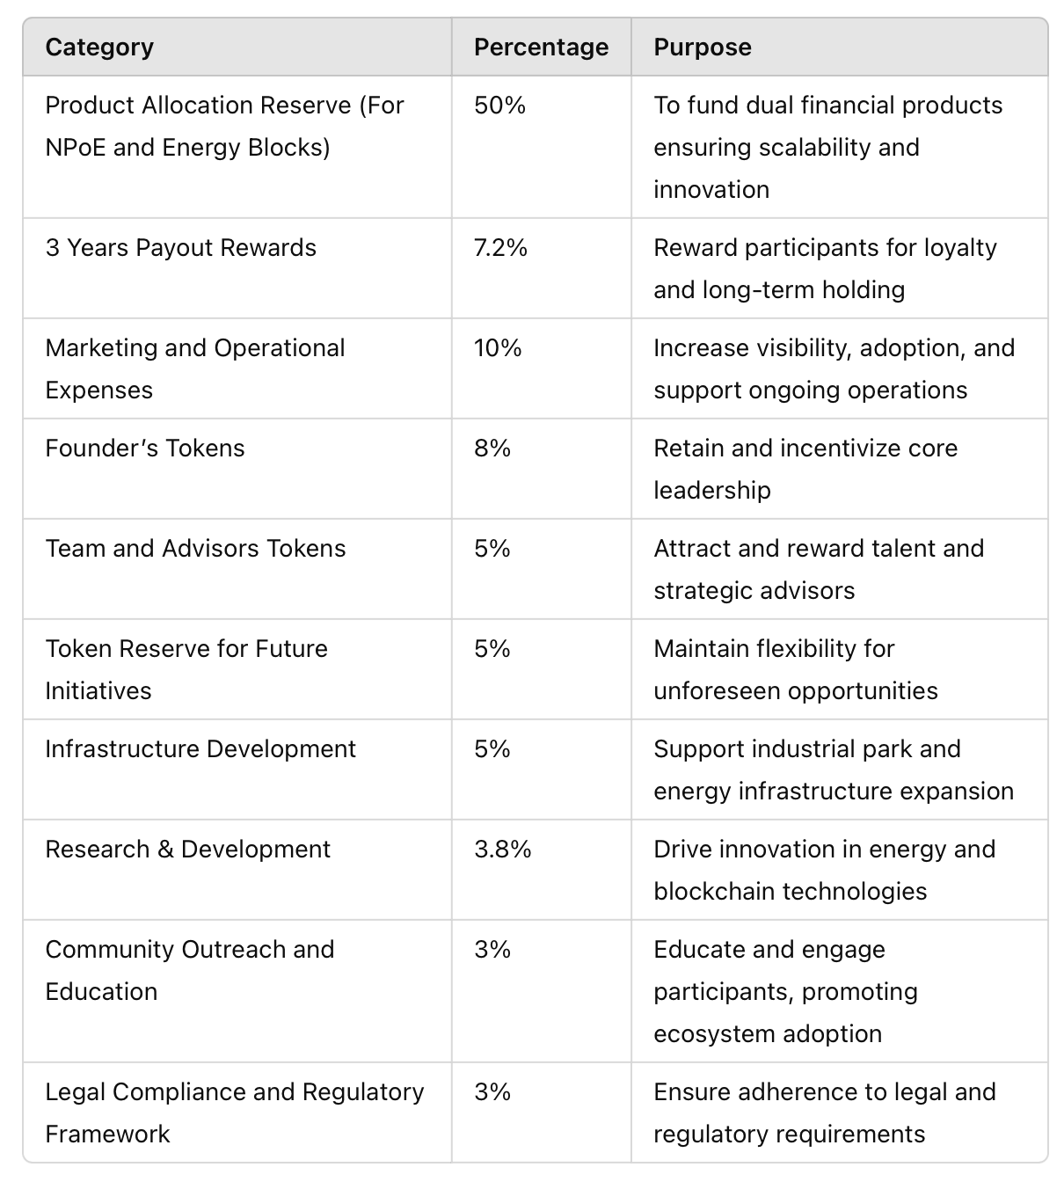

Token Supply and Pricing
Strategic Pricing and Placement
- The presale price of USD 0.001 offers an accessible entry point, fostering inclusivity for a wide range of participants.
- With only 15% of the supply initially floated, scarcity is maintained, supporting early price appreciation.
Phased Distribution
- Phase 1: Initial Fundraising
  - Objective: Raise USD 500,000 to establish the NEXT ecosystem.
  - Token Float: 500 million tokens (part of the 15% allocation).
  - Buy-Back Assurance: Contributions are secured by a buy-back mechanism, ensuring redemption after 365 days for participant liquidity and predictable returns.
- Phase 2: Public Listing
  - Objective: Raise USD 5-10 million by transitioning from private fundraising to exchange trading.
  - Outcome: Enhances liquidity, visibility, and adoption, driving increased demand and trading activity.
- Phase 3: Energy Finance Products
  - Concept: Introduce tokenized energy block trading through NEXT Proof of Energy (NPoE).
  - Returns: Participants earn 20%-24% annually, with monthly payouts of 1.6%-2%.
  - Mechanism: Governed by smart contracts for secure and transparent transactions.
- Phase 4: Yield Distribution
  - Objective: Reward long-term holders with yeilds tied to NEXT’s profitability.
  - Structure:
    - Semi-annual Yield distribution (June and December).
    - Participants must hold tokens for at least 6 months to qualify.
    - Yeilds reflect NEXT’s business performance, aligning participant rewards with ecosystem growth.

Mechanisms to Drive Value
1. Scarcity and Controlled Supply
- Initial float of 15% incentivizes holding and drives price appreciation.
2. Utility-Driven Demand
- Tokens are required for utility payments, rentals, and transactions in industrial parks and data centers.
3. Predictable Returns
- Energy finance products (NPoE and Power Blocks) offer annual returns, incentivizing engagement.
4. Yield Incentives
- Long-term holders benefit from semi-annual yeilds, fostering loyalty and reducing token circulation.
5. Scalability and Growth
- Tokens fund the expansion of industrial parks and renewable energy projects, ensuring scalability and continuous demand.

Participant Benefits
- Accessible Entry: Presale price of USD 0.001 ensures inclusivity for a wide range of participants.
- Predictable Returns: Steady annual returns of 20%-24% attract retail and institutional participants alike.
- Yield Rewards: Semi-annual yeilds provide additional incentives for long-term holding.
- Utility-Driven Ecosystem: Tokens play a critical role in industrial park operations, creating consistent demand.
- Long-Term Value: Scarcity and utility-driven demand ensure sustainable value appreciation.

Conclusion
NEXT Tokenomics reflect a carefully crafted balance between scarcity, utility, and participant incentives. By floating only 15% of the total supply at an accessible price of USD 0.001, the model ensures early appreciation and scalability.
With predictable returns, utility-driven demand, and yeilds for long-term holders, NEXT Token creates an unparalleled opportunity for participants to engage in a robust, scalable ecosystem that bridges energy and finance.

Part 11: Roadmap
NEXT: A Vision for the Future of Energy and Finance
The NEXT roadmap outlines a clear, phased approach to achieving global leadership in energy finance and industrial ecosystems. With a strong foundation and strategic milestones, NEXT ensures scalability, innovation, and sustainable growth for participants and stakeholders.

Roadmap Phases
Phase 1: Foundation and Initial Launch (Year 1)
- Establish the First NEXT Industrial Park:
  - Secure 100 hectares of land and develop infrastructure, including energy substations, roads, and data center facilities.
  - Integrate energy generation with 1,000 MW capacity to support industrial and residential needs.
- Token Launch and Presale:
  - Distribute 15% of total tokens at the presale price of USD 0.001 to raise foundational capital.
  - Introduce buy-back mechanisms to ensure participant liquidity and predictable returns.
- Launch Initial Products:
  - Roll out NEXT Proof of Energy (NPoE) and Power Blocks to engage early participants.

Phase 2: Regional Expansion and Market Growth (Years 2–3)
- Expand Industrial Parks:
  - Acquire an additional 1,000 hectares of land to develop up to five industrial parks in key global regions.
  - Scale energy production to 3,000 MW to meet growing demand.
- Enhance Token Utility:
  - Increase adoption by integrating NEXT Token as the primary currency for utilities, rentals, and services in industrial parks.
- Global Partnerships:
  - Strengthen partnerships with governments, institutional investors, and technology providers to drive scalability and trust.
- Energy Finance Expansion:
  - Introduce additional energy block trading opportunities to expand participation and token utility.

Phase 3: Global Leadership and Innovation (Years 4–5)
- Scale Energy Capacity to 5,000 MW:
  - Ensure sufficient energy generation to power industrial parks, data centers, and regional economies.
- Establish NEXT as the Global e-Fi Leader:
  - Lead the energy finance (e-Fi) space through the adoption of NPoE and Power Blocks worldwide.
  - Position the NEXT Token as the preferred currency for energy finance and industrial transactions.
- Develop Smart Energy Solutions:
  - Integrate IoT and blockchain technology to create energy-efficient, data-driven ecosystems.
- NEXT Energy Digital Index (NEDI):
  - Expand NEDI to facilitate global energy trading, creating transparency and accessibility for participants.

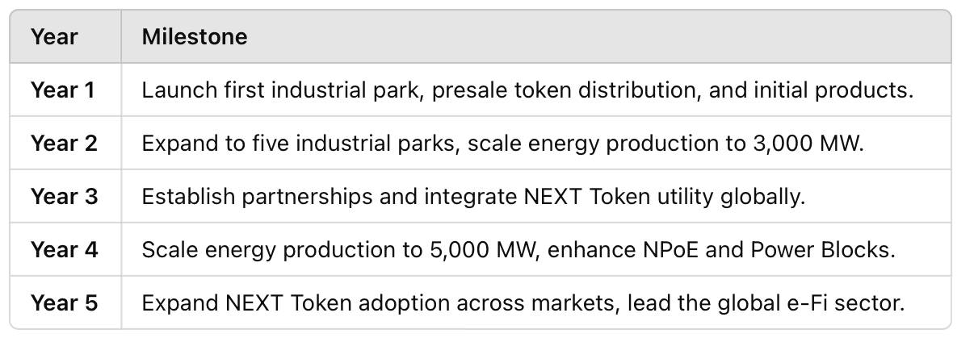
Key Milestones

Strategic Focus Areas
- Scalability: Modular industrial park and energy infrastructure design ensures rapid expansion into high-demand markets.
- Sustainability: Commitment to renewable energy integration and ESG standards to attract environmentally conscious participants.
- Innovation: Continuous investment in blockchain, IoT, and energy-efficient solutions to maintain a competitive edge.
- Participant Value: Enhance returns through yeilds, predictable payouts, and long-term token value appreciation.

Conclusion
The NEXT roadmap reflects a clear and achievable vision for the future of energy finance and industrial ecosystems. By focusing on phased development, global expansion, and innovation, NEXT creates a scalable and sustainable ecosystem that delivers unmatched value for participants and stakeholders alike.
NEXT’s commitment to long-term growth ensures it remains at the forefront of energy-driven digital finance, making it a compelling choice for those seeking stability, returns, and a stake in the future of energy.

Part 12: Risk Management
Ensuring Long-Term Stability for Participants
NEXT has implemented a comprehensive risk management strategy to mitigate potential challenges and ensure the long-term stability and success of the ecosystem. By proactively addressing operational, financial, and market risks, NEXT creates a secure and resilient environment for participants and stakeholders.

Key Risk Areas and Mitigation Strategies
1. Market Volatility
- Risk: Token prices can be influenced by external market conditions and speculative trading.
- Mitigation:
  - Controlled Supply: Limited initial float (15%) ensures scarcity and prevents oversupply.
  - Real-World Utility: By tying token demand to essential services like energy payments and rentals, NEXT reduces speculative volatility.
  - Gradual Expansion: Tokens are strategically released to align with ecosystem growth, avoiding sudden market disruptions.

2. Regulatory Compliance
- Risk: Changing regulatory environments may impact the operation and adoption of blockchain-based ecosystems.
- Mitigation:
  - Proactive Engagement: NEXT works closely with regulatory bodies to ensure compliance across all jurisdictions.
  - Dedicated Legal Framework: A portion of funds is allocated to legal and compliance efforts, ensuring the ecosystem operates within global legal standards.
  - Transparency: Blockchain-based systems ensure transactions are transparent and auditable, building trust with regulators.

3. Technology and Security
- Risk: Potential vulnerabilities in blockchain, smart contracts, or energy infrastructure could disrupt operations.
- Mitigation:
  - Smart Contract Audits: All contracts are audited by third-party security firms to prevent vulnerabilities.
  - Advanced Security Protocols: NEXT employs robust cybersecurity measures to protect the ecosystem.
  - Redundancy in Infrastructure: Critical systems have redundancy to ensure uninterrupted energy supply and operations.

4. Energy Supply and Infrastructure Risks
- Risk: Dependence on energy infrastructure could expose the ecosystem to operational or environmental risks.
- Mitigation:
  - Diversified Energy Sources: NEXT integrates renewable energy (solar, wind, etc.) to reduce reliance on any single source.
  - Scalability: Modular Power Blocks allow for incremental capacity expansion, minimizing operational strain.
  - Environmental Management: NEXT aligns with ESG standards to mitigate environmental risks and attract sustainability-focused participants.

5. Participant Liquidity Risks
- Risk: Participants may face liquidity challenges if token demand or trading volume decreases.
- Mitigation:
  - Buy-Back Mechanism: Participants are assured of liquidity through a structured buy-back program during initial fundraising phases.
  - Token Utility: Continuous integration of the NEXT Token into real-world applications ensures ongoing demand and liquidity.
  - Exchange Listings: Strategic token listings on reputable exchanges enhance market depth and trading volume.

6. Competitive and Market Risks
- Risk: Competitors or market changes could affect NEXT’s position in the energy and blockchain sectors.
- Mitigation:
  - First-Mover Advantage: As the first energy-focused digital asset with real-world utility, NEXT establishes a strong market presence.
  - Continuous Innovation: Investments in R&D ensure NEXT stays ahead of technological and market trends.
  - Strategic Partnerships: Collaborations with Subana Jurong and other industry leaders strengthen NEXT’s market position.

Participant Protection Measures
- Transparency:
  - What ahBlockchain technology ensures all transactions are visible, auditable, and immutable.
- Smart Contract Security:
  - Regular audits ensure that smart contracts remain secure and reliable.
- Compliance Assurance:
  - NEXT operates within global regulatory frameworks, protecting participants from legal risks.
- Redundancy and Resilience:
  - Energy and infrastructure redundancies ensure uninterrupted operations, safeguarding participant investments.

Conclusion
NEXT’s comprehensive risk management strategy ensures a secure, transparent, and resilient ecosystem. By addressing potential challenges proactively, NEXT protects participant interests and builds trust in its operations.
Through its focus on regulatory compliance, technological innovation, and operational stability, NEXT minimizes risks while maximizing growth opportunities for participants. This robust framework positions NEXT as a reliable and sustainable choice for stakeholders in the energy and digital finance sectors.

Part 13: Legal Compliance and Regulatory Framework
Operating with Integrity and Adherence to Global Standards
NEXT is committed to ensuring its operations comply with international legal and regulatory standards. A robust legal and compliance framework underpins the ecosystem, fostering trust and security for participants and stakeholders.

Regulatory Compliance
1. Global Compliance Standards
- NEXT aligns with regulations in key jurisdictions where it operates, ensuring adherence to energy, finance, and blockchain standards.
- Dedicated legal teams monitor evolving regulations and adapt the ecosystem to remain compliant with global and regional requirements.
2. Licensed Operations
- NEXT partners with regulatory authorities to obtain necessary licenses for energy generation, token operations, and industrial park development.
- Partnerships with reputable legal advisors ensure that all operations are within the bounds of law.
3. Anti-Money Laundering (AML) and Know Your Customer (KYC)
- NEXT implements stringent AML and KYC policies to prevent illegal activities and ensure the integrity of the ecosystem.
- Participants undergo a secure and efficient verification process during onboarding.

Smart Contract Governance
1. Secure and Auditable Contracts
- All smart contracts within the NEXT ecosystem are regularly audited by leading blockchain security firms to ensure robustness and prevent vulnerabilities.
2. Automation of Compliance
- Smart contracts integrate compliance protocols, automating processes like token transactions, rewards distribution, and Yield payouts while ensuring alignment with regulatory standards.

Participant Protection
1. Transparent Transactions
- Blockchain technology ensures all transactions are immutable and publicly visible, providing participants with real-time transparency.
2. Fund Security
- Funds raised during token sales are held securely in multi signature wallets, reducing the risk of mismanagement or fraud.
3. Dispute Resolution
- NEXT provides a clear framework for dispute resolution, ensuring fair treatment and quick resolution of any issues raised by participants or partners.

Adapting to Regulatory Changes
1. Proactive Monitoring
- The legal and compliance team actively monitors changes in global regulations to ensure NEXT remains ahead of potential legal challenges.
2. Flexible Framework
- NEXT’s operational framework is designed to adapt to new legal requirements, ensuring continuous compliance without disrupting ecosystem operations.
3. Collaboration with Authorities
- NEXT works closely with regulatory authorities to establish itself as a trusted and transparent player in the energy and digital finance sectors.

Risk Mitigation through Compliance
- Legal Risks: Regular audits and adherence to licensing requirements minimize the risk of legal disputes.
- Market Risks: Compliance with global financial standards fosters trust among participants, reducing market-related risks.
- Operational Risks: Smart contract automation ensures consistent adherence to compliance standards, minimizing operational inefficiencies.

Commitment to Ethical Practices
NEXT adheres to the highest standards of ethical practices, ensuring all operations are conducted transparently and responsibly. This commitment includes:
- Respecting privacy and data security for all participants.
- Operating with fairness and inclusivity across all ecosystem activities.
- Promoting sustainability and environmental responsibility in all projects.

Conclusion
NEXT’s legal compliance and regulatory framework reflect its dedication to transparency, security, and integrity. By aligning with global standards and proactively addressing legal and regulatory requirements, NEXT builds trust and confidence among participants and stakeholders.
This robust framework ensures NEXT operates as a reliable and sustainable entity in the energy and digital finance sectors, paving the way for long-term success and stability.

Part 14: Appendices
Supplementary Information for Participants and Stakeholders
The appendices provide additional details and references to support the main content of the white paper, ensuring transparency and clarity for all participants. This section also includes definitions, data points, and references relevant to NEXT's ecosystem, operations, and tokenomics.

Appendix A: Key Definitions
- Energy Finance (e-Fi)
  - A financial model that integrates blockchain technology with energy trading, enabling participants to tokenize energy assets and generate returns.
- NEXT Proof of Energy (NPoE)
  - A blockchain-based energy trading system that offers participants predictable returns through tokenized energy block trading.
- Power Blocks
  - Modular, tokenized energy assets that provide participants with consistent daily payouts and principal security over a defined term.
- ESG (Environmental, Social, and Governance)
  - A set of standards used to evaluate a company's commitment to sustainable and ethical practices.
- Smart Contracts
  - Blockchain-based programs that execute predefined rules automatically, ensuring transparency and security for all transactions.

Appendix B: Tokenomics Summary
- Total Supply: 50 billion NEXT Tokens.
- Initial Market Placement: 15% (7.5 billion tokens).
- Presale Price: USD 0.001 per token.
- Market Cap: USD 7.5 million (floating), USD 50 million (total).

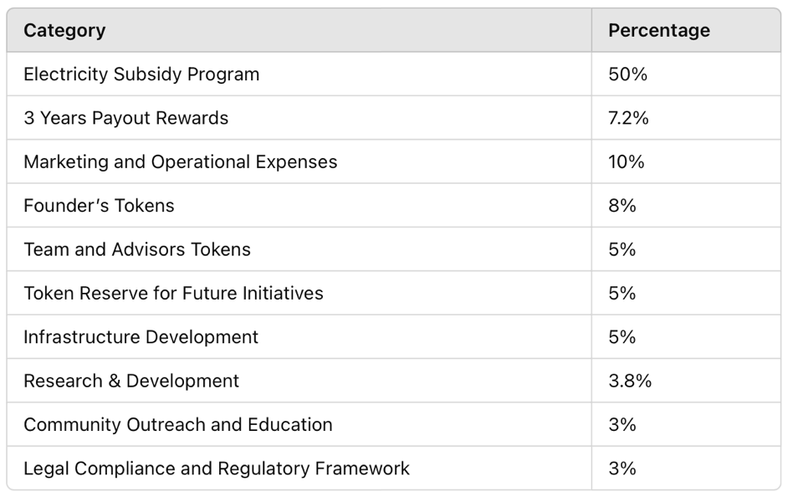
Allocation Overview:

Appendix C: Roadmap Timeline

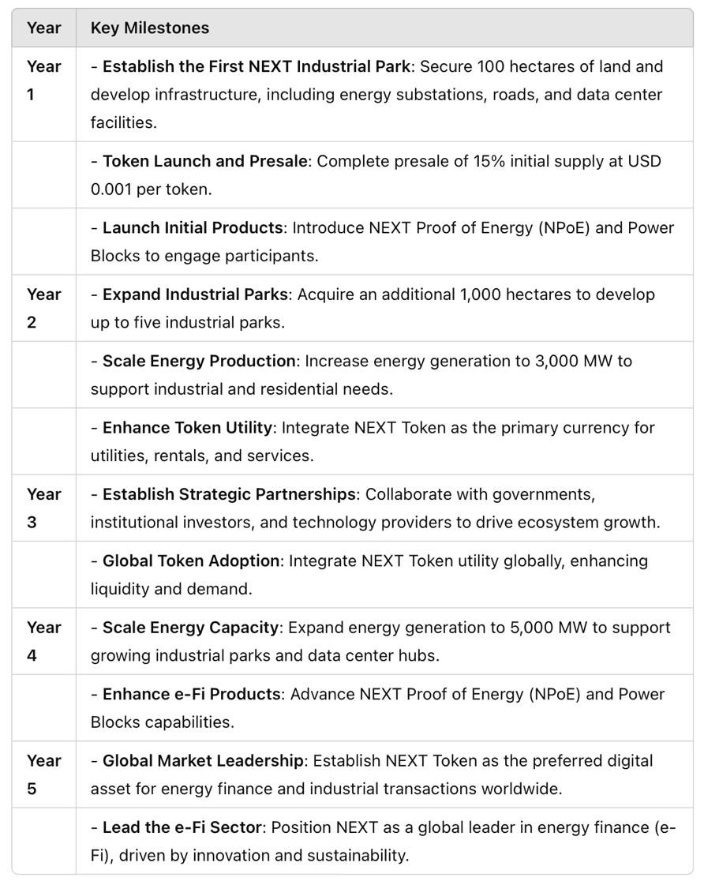
The roadmap outlines NEXT’s phased development and strategic expansion over five years, reflecting the project’s commitment to scalability, sustainability, and global impact.

Appendix D: Risk Management Framework
Key Risk Areas:
- Market Volatility
- Regulatory Compliance
- Technology and Security
- Energy Supply and Infrastructure Risks
- Participant Liquidity Risks
- Competitive and Market Risks
Mitigation Strategies:
- Controlled supply and utility-driven demand to stabilize token value.
- Proactive regulatory compliance and smart contract audits.
- Diversification of energy sources and robust infrastructure.

Appendix E: Frequently Asked Questions (FAQs)
1. What is NEXT Token’s primary use?
NEXT Token is integrated into industrial parks and data centers, serving as the primary currency for energy payments, rentals, and transactions. It also powers energy finance products like NPoE and Power Blocks.
2. How does NEXT ensure token stability?
Through controlled token supply, real-world utility, and continuous demand generated by industrial operations.
3. What returns can participants expect?
NEXT Proof of Energy (NPoE) offers competitive annual returns, while Power Blocks provide consistent daily payouts and principal security.
4. How is NEXT aligned with ESG standards?
NEXT incorporates renewable energy projects, sustainable industrial park development, and environmentally conscious practices into its operations.

Appendix F: Contact Information
For inquiries and support:
- Official Website: www.thenext.energy
- Email Support: info@thenew.energy

4. Key Milestones

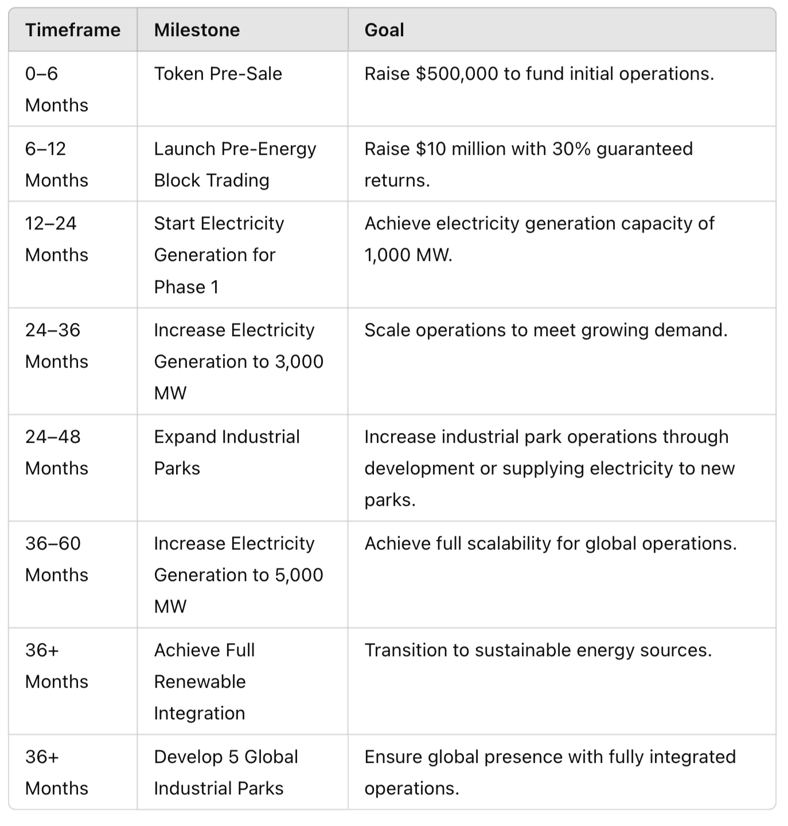

5. Focus Areas for Execution

a. Scalability and Sustainability
- Modular growth of industrial parks and electricity generation ensures the ecosystem remains scalable and adaptable to increasing demand.
- Emphasis on renewable energy integration aligns with global environmental goals.

b. Technology and Innovation
- Continuous enhancement of blockchain technology to ensure seamless token transactions, staking, and governance.
- Expansion of smart contract capabilities to accommodate evolving market demands.

c. Strategic Partnerships
- Ongoing collaboration with industrial park developers, renewable energy providers, and blockchain innovators to accelerate growth.

Conclusion
The NEXT Token roadmap is a testament to its scalability, vision, and commitment to long-term success. From initial fundraising and pre-energy block trading to global industrial park expansion and renewable energy integration, the roadmap outlines a clear path toward becoming the leading energy-Based digital asset.
By achieving these milestones, NEXT Token not only delivers consistent returns to its investors but also establishes itself as a transformative force in the energy-Based digital economy.

Part 11: Market Opportunity and Competitor Analysis

Introduction
The NEXT Token is uniquely positioned at the intersection of energy, technology, and blockchain. As energy demand continues to rise globally and cryptocurrency adoption accelerates, NEXT Token’s energy-supported financial ecosystem offers a compelling solution for investors seeking stability, scalability, and real-world utility. This section explores the market opportunities, trends, and how NEXT Token differentiates itself from competitors.

1. Market Trends and Growth Potential

a. Increasing Global Energy Demand
- The world’s energy demand is expected to grow by over 50% by 2050, driven by industrialization, urbanization, and the rise of data-driven economies.
- Data centers and industrial parks are among the largest energy consumers, with data centers alone accounting for 1% of global electricity consumption and expected to double by 2030.
- Renewable energy adoption is accelerating, aligning with global environmental goals and creating opportunities for sustainable energy-based solutions.

b. Volatility in Traditional Cryptocurrency Markets
- Cryptocurrencies are often criticized for their speculative nature and lack of real-world utility.
- NEXT Token addresses this gap by anchoring its value to tangible energy production and operational use cases, making it a more stable and reliable investment.

c. The Rise of Tokenized Assets
- Tokenization of real-world assets, such as energy, is gaining traction as investors seek diversified opportunities in decentralized finance (DeFi).
- NEXT Token’s integration with energy block trading positions it as a pioneer in the energy finance (e-Fi) space, tapping into a rapidly growing market.

2. Competitive Advantage of NEXT Token

a. Real-World Utility
NEXT Token stands out with its direct integration into industrial parks and data centers:
- Used for payments of utilities, rentals, and services.
- Offers tokenized energy block trading with guaranteed returns, creating immediate and tangible value for participants.

b. Supported by Energy, the Only Increasing Commodity
- Electricity is the only commodity that has never seen a sustained price drop, unlike volatile commodities like gold, oil, or cryptocurrencies.
- NEXT Token leverages this inherent stability, providing a consistent revenue base that supports long-term growth and value appreciation.

c. Predictable Returns and Yeilds
- While most cryptocurrencies rely on speculative trading, NEXT Token offers 20%-30% PA, subject to market conditions but ensuring consistent positive growthannual returns through energy block trading and annual yeilds for long-term holders.

d. Controlled Supply and Scarcity
- By placing only 15% of the total 50 billion token supply into the market, NEXT Token ensures scarcity, encouraging demand and price appreciation.

e. Scalable Ecosystem
- NEXT Token is designed to scale alongside NewX’s operations, including industrial park expansion and increased electricity generation, further driving its utility and value.

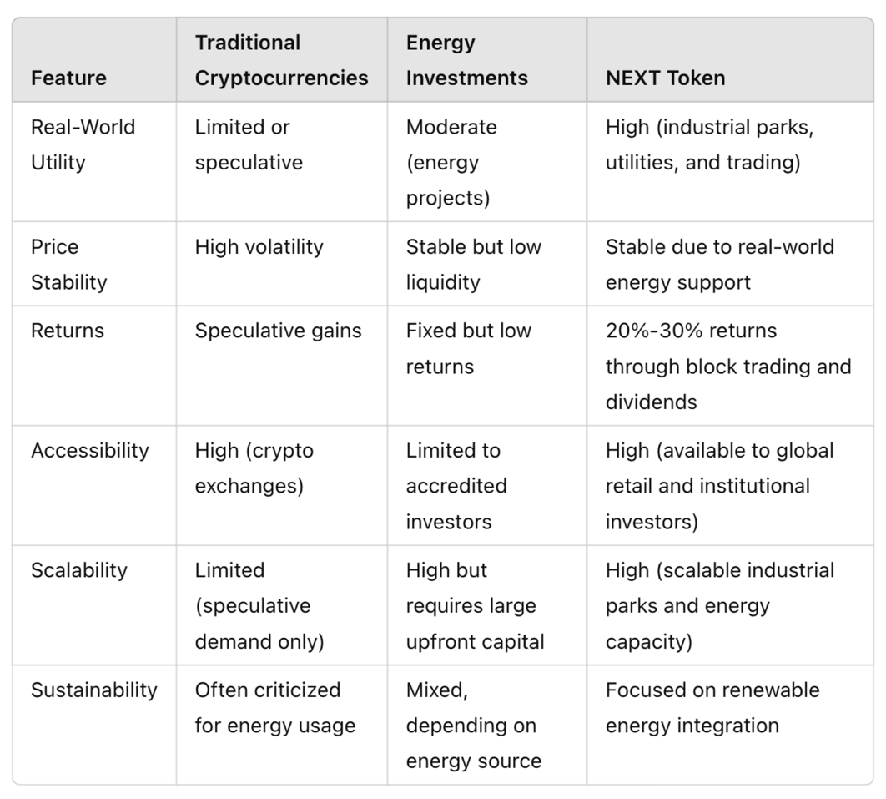
3. Comparison with Competitors
4. Why Investors Are Choosing NEXT Token?

a. Diversification with Real-World Assets
NEXT Token offers exposure to the energy sector without traditional barriers, such as high upfront capital or limited access to energy investments.

b. Predictable and Competitive Returns
- Energy-based returns are more predictable compared to speculative cryptocurrencies.
- Yeilds and price appreciation add further value for long-term holders.

c. Alignment with Sustainability Goals
NEXT Token supports renewable energy initiatives, making it an attractive option for ESG-conscious investors.

d. First-Mover Advantage
- NEXT Token’s integration of blockchain with energy finance (e-Fi) positions it as a leader in this emerging space.
- Its unique combination of energy-supported assets, scalable utility, and guaranteed returns sets it apart from competitors.

5. Future Market Opportunities

a. Expanding the Energy-Based Ecosystem
- NEXT Token’s scalable model allows for integration into additional industrial parks and energy projects globally, tapping into a larger market over time.

b. Institutional Interest
- As energy block trading gains traction, institutional investors are likely to participate, increasing demand for NEXT Token.

c. Renewable Energy Transition
- The shift to renewable energy presents opportunities for NEXT Token to expand its ecosystem while aligning with global environmental goals.

d. Digital Economy Integration
- NEXT Token can integrate with emerging technologies, such as IoT (Internet of Things) and AI, to optimize industrial park operations and energy management.

Conclusion
NEXT Token is uniquely positioned to capture the growing demand for stable, energy-based digital assets. By leveraging the stability of electricity, the scalability of its ecosystem, and its integration with real-world operations, NEXT Token provides a compelling alternative to traditional cryptocurrencies and energy investments.
With predictable returns, yeilds for long-term holders, and alignment with sustainability goals, NEXT Token stands out as a transformative force in the digital and energy economies. Its first-mover advantage in energy finance (e-Fi) positions it as a leader in this emerging market, offering investors a unique opportunity to participate in a secure, scalable, and innovative ecosystem.

Part 12: Conclusion and Call to Action

Introduction
The NEXT Token represents a transformative opportunity in the intersection of energy, technology, and finance. By anchoring its value to real-world energy production and creating a scalable ecosystem integrated with industrial parks, energy block trading, and blockchain technology, NEXT Token offers investors an innovative, stable, and high-growth potential digital asset.
This final section summarizes the key benefits of NEXT Token, outlines its long-term vision, and encourages investors to join this ground breaking project.

1. Summary of Key Benefits

a. Real-World Utility and Stability
- Unlike speculative cryptocurrencies, NEXT Token derives its value from tangible energy production, ensuring stability and predictable returns.
- Integrated with industrial parks and data centers, NEXT Token serves as the medium for utilities, rentals, and operational payments, driving continuous demand.

b. Predictable and Competitive Returns
- Participants can achieve returns of 20%-30% PA, subject to market conditions but ensuring consistent positive growthannually through energy block trading, supported by smart contracts that guarantee pay-outs.
- Long-term holders benefit from annual yeilds tied to NEXT’s profitability, further incentivizing loyalty and creating additional revenue streams.

c. Scalable and Sustainable Growth
- NEXT Token’s scalability is tied to the expansion of electricity generation capacity (targeting 5,000 MW) and the development of industrial parks globally.
- Emphasis on renewable energy integration ensures alignment with global sustainability goals, making NEXT Token attractive for ESG-focused investors.

d. Controlled Supply and Price Appreciation
- With only 15% of the total 50 billion token supply initially placed in the market, NEXT Token maintains scarcity, encouraging price appreciation and long-term value growth.

e. First-Mover Advantage in Energy Finance (e-Fi)
- NEXT Token’s unique combination of blockchain and energy-backed assets positions it as a leader in the emerging energy finance (e-Fi) space, offering a compelling alternative to traditional investments.

2. Vision for the Future

a. Revolutionizing the Energy Economy
NEXT Token aims to reshape the energy market by creating a seamless connection between energy production, blockchain technology, and digital finance.

b. Expanding Global Operations
- NEXT plans to develop five industrial parks globally, each integrated with renewable energy solutions and powered by NEXT Token.
- The scalable model allows for rapid expansion, with plans to supply energy to additional industrial parks or partner projects worldwide.

c. Promoting Renewable Energy Adoption
As the world transitions to renewable energy, NEXT Token’s ecosystem will play a pivotal role in promoting sustainable energy practices while offering investors competitive returns.

d. Creating a Self-Sustained Digital Economy
The NEXT Token ecosystem is designed to be self-sustaining, with continuous demand generated through energy block trading, industrial park operations, and global partnerships.
3. Call to Action

Why Participate in NEXT Token?
- A Unique Opportunity: NEXT Token is the first of its kind, combining energy production, blockchain technology, and financial returns in a single ecosystem.
- Stability with Growth Potential: Anchored to electricity—the only commodity with a consistent price increase—NEXT Token offers unparalleled stability and growth opportunities.
- Be Part of the Future: Joining NEXT Token means supporting a global shift toward sustainable energy while benefiting from predictable returns and long-term value appreciation.

How to Get Started?
- Step 1: Participate in the pre-sale at $0.001 per token and secure an early position in this high-demand ecosystem.
- Step 2: Explore energy block trading with guaranteed returns of 30% annually during the introduction phase.
- Step 3: Hold NEXT Tokens for over one year to qualify for annual yeilds and maximize your long-term investment potential.

Contact and Community Engagement
Stay connected and informed about NEXT Token’s developments:
- Visit our website to access the latest updates and investor resources.
- Join our community forums, social media channels, and newsletters to participate in discussions and receive timely updates.
- Contact our support team for inquiries about investments, tokenomics, or partnership opportunities.

Conclusion
NEXT Token is more than just a cryptocurrency—it’s a transformative solution at the forefront of energy finance, digital assets, and sustainable growth. By aligning with real-world utility, scalability, and renewable energy integration, NEXT Token is uniquely positioned to lead the energy-backed digital economy.
Participate today to be part of the NEXT revolution and secure your place in a future where energy, technology, and finance converge to create unparalleled opportunities for growth, stability, and impact

